**Brooklyn torah gazette**

**For parshas korach 5783**

Volume 7, Issue 40 (Whole Number 347) 5 Tammuz 5783/ June 24, 2023

**Printed L’illuy nishmas Nechama bas R’ Noach, a”h**

For a free subscription, please forward your request to [***keren18@juno.com***](mailto:keren18@juno.com)

**Can AI Replace Rabbis?**

**By**[**Yehuda Shurpin**](https://www.chabad.org/search/keyword_cdo/kid/15169/jewish/Shurpin-Yehuda.htm)

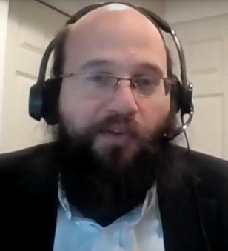

**Rabbi Yehuda Shurpin**

I’m glad you're asking a rabbi about whether he is replaceable! That’s like asking an employee about the prospect of being replaced with automation.

I assume your question isn’t about replacing the rabbi’s role as mentor, given that AI (Artificial Intelligence) lacks human experiences, emotions, and the ability to empathize. Much of what a rabbi does involves connecting with individuals on a personal and emotional level, understanding their unique circumstances within the greater context, and providing guidance accordingly. AI cannot replicate the depth of human connection required for spiritual counseling and support.

Rather, your question seems to be about asking halachic questions to a chatbot instead of a rabbi.

The truth is that, unlike a typical employee being replaced by an AI, many rabbis would welcome a possible alternative. After all, they would love nothing more than to spend their time learning more Torah. As for their livelihood, they know that G‑d can provide everyone with their livelihood regardless of AI. Unfortunately, however, a chatbot does not a rabbi make.

Here’s why:

**Are Chatbots and AI even accurate?**

If one is simply seeking information about what a specific halachic text has to say, an AI can be a valuable tool for information gathering and [Torah](https://www.chabad.org/library/article_cdo/aid/1426382/jewish/Torah.htm) study. It can provide access to a wide range of sources and help compile comprehensive summaries of various opinions and texts.

Yet, despite AI’s significant advancements in various fields, it still has a very long way to go to provide reliable and accurate information, especially in the realm of *halachah*.



*Art by*[*Sefira Lightstone*](https://www.chabad.org/3159160)

**Within the Framework of Halachah**

Torah texts often require nuanced interpretation, taking into account historical and contextual factors. AI systems typically operate on data-driven algorithms and lack the ability to grasp the intricacies of religious teachings. A human rabbi (hopefully!) possesses years of training, study and understanding of the text, allowing him to provide guidance within the framework of *halachah*.

A second issue is that the programming of AI introduces a significant challenge. The values and halachic rulings programmed into AI systems inherently reflect a bias, influenced by the beliefs and interpretations of those who develop the algorithms. This bias may lead to the exclusion or prioritization of certain opinions, potentially distorting the halachic landscape presented by AI. The acceptance or rejection of controversial topics can greatly impact the AI's conclusions, steering it in specific directions that may not align with *halachah*.

But let us assume, for argument's sake, that an AI has somehow overcome all of these challenges and has also advanced significantly to the point where it can gather and present unbiased information.

Knowing accurate information and data is merely one component of determining what the correct*halachah* is.

***Shimush* and the Practicing Rabbi**

Countless letters and talks from the Lubabitcher Rebbe emphasize (and admonish!) that if a question arises in *halachah*, it is not enough to just ask someone who was ordained and has the title “rabbi”; the rabbi needs to be a *practicing* rabbi who has *shimush,* the experience that comes from apprenticing with a veteran rabbi.[1](javascript:doFootnote('1a5981878');)

The sages of the Talmud[2](javascript:doFootnote('2a5981878');) discuss “one who read and learned but did not serve Torah scholars (*shimush*)”:

Rabbi Elazar says: This person is an ignoramus.  
Rabbi Shmuel bar Naḥmani said: This person is a boor.

Rabbi Yannai says: This person is comparable to a Samaritan (i.e., follows the Written Torah but not the traditions of the sages).

Clearly, *shimush*is critical.

Shimush involves actively engaging with experienced and knowledgeable authorities, observing their methodologies, and gaining hands-on experience in halachic decision-making. This apprenticeship-like approach is crucial to developing practical skills, judgment, and insights into halachic practice, which can’t be gained by reading text and gathering information.[3](javascript:doFootnote('3a5981878');)

**The Importance of Mesorah (Tradition)**

On the same note, Mesorah (tradition) plays a crucial role in halachic decision-making. AI lacks the ability to access anecdotal material or personal experiences passed down through generations of scholars. Mesorah encompasses not only the oral teachings received from one's teacher, but also the observation of how the teacher applied halachic rulings in practical cases.[4](javascript:doFootnote('4a5981878');)

An intriguing statement often quoted in *halachah* is that “the opinion of the lay people is the opposite of the Torah’s opinion.”[5](javascript:doFootnote('5a5981878');)

The Lubavitcher Rebbe explains that this refers to people who have indeed learned and are perhaps very knowledgeable in *halachah*. However, even such individuals miss a vital component of the halachic decision-making process if they lack practical experience.[6](javascript:doFootnote('6a5981878');)

It is not for naught that the [Talmud](https://www.chabad.org/library/article_cdo/aid/2537389/jewish/Talmud.htm) states, “*Shimush* is even greater than learning.”[7](javascript:doFootnote('7a5981878');)

In other words, an AI may have learned a lot and appear more “knowledgeable” in many ways, but it may still be considered “an ignoramus” for our purposes.

Although we may not technically have the original *semichah* (see [What Is a Rabbi? - A Brief History of Rabbinic Ordination (Semichah)](https://www.chabad.org/library/article_cdo/aid/1933944/jewish/What-Is-a-Rabbi.htm)), for one to be considered a rabbi, he still needs to be ordained and have *shimush*.[8](javascript:doFootnote('8a5981878');)

**Divine Help**

In addition to the reasons outlined above, when a rabbi approaches the halachic decision process with proper preparation (i.e., *shimush*) and the appropriate humility and fear of heaven, then he receives *siyata dishmaya,*help from Heaven, ensuring that he will rule correctly in that specific situation. This is because the rabbi is following what the Torah[9](javascript:doFootnote('9a5981878');) itself enjoins us to do.[10](javascript:doFootnote('10a5981878');)

[A story](https://www.chabad.org/library/article_cdo/aid/109487/jewish/Channels-of-Truth.htm) often relayed by the Lubavitcher Rebbe illustrates this point:

Rabbi Yechezkel Landau, the famed author of *Noda B'Yehuda*, served as the rabbi of Prague from 1754 to 1793. Once a group of scholars who wished to contest his rabbinic qualifications presented him with a series of questions in Torah law. These fictitious "cases" were carefully constructed to be as complex and as misleading as possible, so as to ensnare the rabbi in their logical traps and embarrass him with an incorrect ruling.

Rabbi [Yechezkel](https://www.chabad.org/library/bible_cdo/aid/16098/jewish/Yechezkel-Ezekiel.htm" \o "Yechezkel (Ezekiel)) succeeded in resolving all the questions correctly—all, that is, but one. Immediately, his detractors pounced on him, showing how his verdict contradicted a certain principle of Torah law.

Said Rabbi Yechezkel: "I am certain that this case is not actually relevant, and that you have invented it in order to embarrass me!"

**G-d’s Torah is True**

"How do I know?" the rabbi continued. "Because I know that [G‑d](https://www.chabad.org/library/article_cdo/aid/433240/jewish/God.htm)'s Torah is true. You see, whenever a human being is called upon to decide a matter of Torah law, we are faced with a paradox: how can the human mind possibly determine G‑d's will? The laws of Torah are the wisdom and will of G‑d and the most basic laws of reality, preceding and superceding even the laws of nature. How is it that the finite and error-prone intellect is authorized to decide such Divine absolutes?

"But the Torah itself instructs that 'the Torah is not in heaven' but has been given to man to study and comprehend, and that whenever a question or issue of Torah law is raised, it is the human being, employing his finite knowledge and judgment, who must render a ruling. In other words, when a person puts aside all considerations of self and totally surrenders his mind to serve the Torah, G‑d guarantees that the result will be utterly consistent with His will.

"However," concluded Rabbi Yechezkel, "this 'guarantee' only applies to actual events, when a rabbi is called upon to determine what it is that G‑d desires to be done under a given set of circumstances, but not if his personal honor is the only issue at hand. Had you presented me with a relevant question, I know that I would not have erred, since I approached the matter with no interest or motive other than to serve the will of G‑d. But since your case was merely a hypothetical question designed to mislead me, my mind was just like every other mind, great and small alike—imperfect and manipulatable."

Now, while rabbis are assured of this assistance, we have no assurance that the same is granted to algorithms. For a fascinating dive into this topic, see [The Difference Between a Rabbi and a Rav](https://www.chabad.org/library/article_cdo/aid/3753331/jewish/The-Difference-Between-a-Rabbi-and-a-Rav.htm).

**FOOTNOTES**

[1.](https://www.chabad.org/library/article_cdo/aid/5981878/jewish/Can-AI-Replace-Rabbis.htm#footnoteRef1a5981878) See for example *Torat Menachem* 5747 vol. 2 pg 487, *Torat Menachem*5750 vol. 4 pg 26; See also Rabbi Avraham Shmuel Buiket in *Rav b’Yisroel*as well as *Rav - Moreh Derech*in which the author compiled many talks and letters from the Lubavitcher Rebbe on this subject.

[2.](https://www.chabad.org/library/article_cdo/aid/5981878/jewish/Can-AI-Replace-Rabbis.htm#footnoteRef2a5981878) Sotah 22a.

[3.](https://www.chabad.org/library/article_cdo/aid/5981878/jewish/Can-AI-Replace-Rabbis.htm#footnoteRef3a5981878) See also *Igrot Moshe, Yoreh De’ah*4:32.

[4.](https://www.chabad.org/library/article_cdo/aid/5981878/jewish/Can-AI-Replace-Rabbis.htm#footnoteRef4a5981878) See *Teshuvot Mishneh Halachot*14:163, where he discusses the concept of using a computer for halachic decisions at length (see also *Mishneh Halachot* 16:63).

[5.](https://www.chabad.org/library/article_cdo/aid/5981878/jewish/Can-AI-Replace-Rabbis.htm#footnoteRef5a5981878) See *Sema, Shulchan Aruch, Choshen Mishpat* 3:13.

[6.](https://www.chabad.org/library/article_cdo/aid/5981878/jewish/Can-AI-Replace-Rabbis.htm#footnoteRef6a5981878) See, for example, Sichot Kodesh 5727 vol. 2 pg. 288; Igrot Kodesh vol. 26 pg 344-6.

[7.](https://www.chabad.org/library/article_cdo/aid/5981878/jewish/Can-AI-Replace-Rabbis.htm#footnoteRef7a5981878) Talmud Berachot 7b.

[8.](https://www.chabad.org/library/article_cdo/aid/5981878/jewish/Can-AI-Replace-Rabbis.htm#footnoteRef8a5981878) See for example *Mishneh Torah, Hilchot Shemitah V’yovel* 10:6; *Teshuvot Harashba* 4:271; *Meri*on Talmud Yoma 26a; *Mishneh Halachot* 16:63.

[9.](https://www.chabad.org/library/article_cdo/aid/5981878/jewish/Can-AI-Replace-Rabbis.htm#footnoteRef9a5981878) See [Deuteronomy 16:8](https://www.chabad.org/9980#v8)-10.

[10.](https://www.chabad.org/library/article_cdo/aid/5981878/jewish/Can-AI-Replace-Rabbis.htm#footnoteRef10a5981878) See, for example, *Torat Menachem* 5742 vol 1 pg. 74, 5750 vol. 4 pg. 27.

Reprinted from the current website of Chabad.Org

**The Importance of Being**

**A “Smart” Jewish Wife**

**From the Teachings of the Lubavitcher Rebbe**

**Rabbi Menachem Mendel Schneerson, Zt”l**

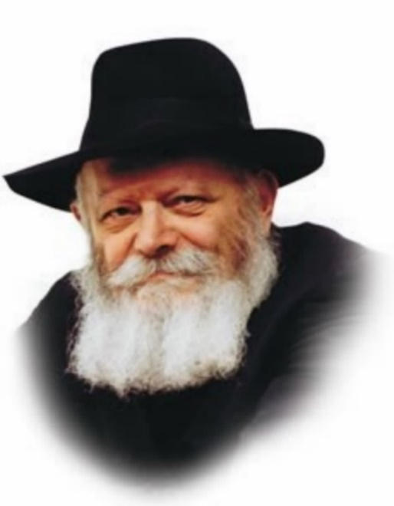

The story related in this week's Torah portion, Korach, contains a lesson for each and every Jew. Korach instigated a rebellion against Moses, for which he and his 250 followers were severely punished.

What do we know about Korach? The Torah relates that Korach was the descendent of one of the most prestigious Jewish families. An outstanding Torah scholar and wise man, he was also very wealthy. Additionally, Korach was on intimate terms with both Moses, the leader of the entire Jewish people, and his brother Aaron, the High Priest.

By contrast, one of Korach's followers, a man by the name of Ohn ben Pelet (the son of Pelet), was none of these. The Torah mentions nothing by which Ohn ben Pelet was distinguished. Ohn ben Pelet was neither particularly clever nor highborn.

It is therefore surprising that each of their lives took such an unexpected turn. In fact, the fates of Korach and Ohn ben Pelet were the exact opposite of what one might anticipate!

The well-connected and intellectually gifted Korach met a bitter end. Not only did he bring himself to ruin, but hundreds of unfortunate Jews who followed his example met with the same fate.

On the other hand, Ohn ben Pelet was saved, together with his entire family. Indeed, he was the only follower of Korach who escaped punishment.

What was the reason for these different outcomes? None other than the conduct of their respective wives, and the influence they wielded over their husbands.

At the very last second, the wife of Ohn ben Pelet rescued her entire family from destruction. His wife was a true "akeret habayit" (mainstay of the home), the epitome and embodiment of the highest ideals of Jewish womanhood.

Korach's wife, by contrast, aided and abetted her husband and his group of rebels through her actions and words. Instead of being an akeret habayit, the ikar (main component) and underlying foundation of the Jewish home, she chose to be an "okeret habayit," literally a woman who destroys and uproots her home.

This story, brought down in the Midrash, reveals the truly momentous responsibility that has been entrusted to the Jewish wife, underscoring her critical role and the extent to which her behavior affects her husband and family. For as King Solomon says in Proverbs, "The wisdom of women builds her house, but folly plucks it down with her hands."

*Reprinted from the Parshat Korach 5760/2000 edition of L’Chaim. Adapted from Volume 2 of Likutei Sichot.*

**Thoughts for the Parsha**

**And Korach.took [a bold step].and they rose up before Moses** (Num. 16:1-2)

The Mishna states in Tractate Avot (5:17): "Which is a controversy that is not for the sake of Heaven? The controversy of Korach and all his faction." The Mishna specifically avoids calling it a controversy between Korach and Moses, because even within Korach's group of 250 followers there was dissention, each one vying with the others for honor and glory. Indeed, this was a sure sign that their argument was not for the sake of Heaven. (Ye'arot Devash)

A person who is broadminded will not respond to taunts, as he is mature enough to disregard them. By contrast, a person who is narrow-minded is unable to tolerate anything that goes against his will, and becomes immediately angered like a young child. In Chasidic terms, unity is derived from "broadness of the intellect"; controversy results from "smallness of intellect." (Maamarei Admor HaZakein)

*Reprinted from the Parshat Korach 5760/2000 edition of L’Chaim.*

**Rav Avigdor Miller**

**On Where is Hashem**

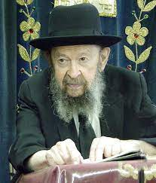

**QUESTION:** How are we to understand the idea that Hashem is bashomayim, that He’s in the heavens or that He sits on a throne?

**ANSWER:** Now let’s understand one thing. There are certain words and attitudes that we learned as children and many people never bothered to re-examine them when they became adults.

You have to understand Hakadosh Baruch Hu is not a guf. He is מלוא כל הארץ כבודו. He has no place. He is called Hamakom because He is the place. Hakadosh Baruch Hu is mekomo shel olam; He is the place of the world. We are in Him. Like Moshe Rabeinu said השם מעון אתה היית לנו – You are our dwelling; we live in You.

So, if you’re going to point now to a place where Hakadosh Baruch Hu is, it means you’re losing sight of the very identity of Hakadosh Baruch Hu. There’s no such thing as place when we’re talking about Hakodosh Boruch Hu.

Now it’s not easy for people to picture such concepts.

But you could try. Let’s imagine you’ll say what is the place of light. Now light is really a physical thing but you can ask where is the place of light. Light starts from the sun, let’s say, and travels to this earth and it goes beyond the earth too. It shines in other places. The moon is on the other side of the earth and the light hits the moon too. Where is the place of light? It’s everywhere. As far as it could travel, it’s everywhere. So lihavdil Hakadosh Baruch Hu is everywhere.

Now you say it’s difficult to conceive. The answer is certainly it’s difficult. You want to understand Hakadosh Baruch Hu?!

So, we say Hashem is in the heavens. Now where is the heavens? At nighttime the heavens are over here and in daytime the heavens are over there. The earth turns. So, you can’t point in one direction. Anyone who wants to point in one direction and say “There’s the heavens” is not talking like an adult. ‘Heavens’ is only a state of existence.

Now we shouldn’t think these are unreal terms. It’s more real than actual heavens. Because if you would point to a certain spot in the sky and be able to say, “There is a big chamber, a tremendous hole and there the Shechinah is!” what you’re doing is profaning the name of Hashem.

**A State Called Heavens**

You’re making Hakadosh Baruch Hu little. Hakadosh Baruch Hu is great and eternal and He lives in a state and that state is called ‘Heavens.’ His existence is called Shomayim. But don’t attempt to point to a place. ‘Heavens’ is not a place; it’s a state. Hakadosh Baruch Hu is an entity that is without any location, but His location is everywhere. מלוא כל הארץ כבודו. He is everywhere.

Now for little children that’s confusing but adults must learn to understand that Hakadosh Baruch Hu is too big for a mind of a person to conceive. It’s like an ant trying to conceive a person.

An ant is underneath this rug, let’s say, and the ant is trying to understand what it means that you’re sitting on a chair on the rug. He can’t picture that. The ant is thinking, “How is it possible for a person to be so big and occupy so much space as a human being does?” An ant can’t picture that. An ant perhaps can picture the sole of your shoe as he encounters it but more than that, his mind totters at the immensity of the concept of a person who will tower up five or six feet above the floor.

And therefore, our minds totter at the reality of Hashem. Only that in order that we shouldn’t slip entirely, we use words. We say השם בשמים הכין כסאו – Hashem established His throne in the heavens. And we live with these words. But we have to know they are only words.

And if you’re asking specifically where is it, the answer is it’s a state of existence of a form that’s far beyond our ability to describe. Anything about Hakadosh Baruch Hu is beyond our ability to describe and that’s why we speak about Him only in picture words.

*Reprinted from a recent email of Toras Avigdor based on Rabbi Miller’s Tape #380 from his classic Thursday night lectures (October 1981)*

**Rabbi Berel Wein on**

**Parshat Korach 5783**

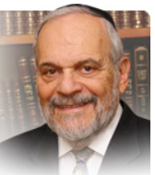

The litany of disappointments and failures, of the generation of Jews that left Egyptian bondage, continues in this week’s parsha. Except, this parsha relates to us not so much in describing a direct confrontation with G-d and His express wishes, so to speak, but rather tells of a challenge to Moshe and his authority to lead the Jewish people. Korach essentially engages in a coup, a power-grabbing attempt to replace Moshe from his leadership role and Aharon from his position as the High Priest of Israel.

Throughout the ages, the Torah scholars and commentators of the Jewish people have attempted to appreciate and understand what Korach’s true motivations were, to engage in such a clearly suicidal attempt. After all, Korach was also aware that Moshe’s countenance radiated Heavenly light that forced him to mask that countenance when dealing with human beings.

Korach was also undoubtedly aware that the High Priesthood and its incense offerings could be deadly to those not entitled to serve in that public role. Again, he saw his relatives, Nadav and Avihu, the sons of Aharon struck down by a heavenly fire, for overstepping their proper bounds in the ritual service of the Mishkan. So, what drove Korach to knowingly risk his life in this doomed and completely unnecessary confrontation with Moshe and Aharon? In the words of Rashi in this week’s parsha: “What did Korach see or think that drove him to commit such a foolish act?” That question has puzzled all of Jewish scholarship for millennia.

It would be brazen of me to say that I somehow have the answer to this deeply troubling question. Nevertheless, I do wish to contribute an insight into the narrative as it appears in the parsha. Like many ideologues, Korach is convinced that G-d agrees with him – that G-d also has realized that Moshe is too autocratic and given to nepotism in his rule of the people. He saw that even Aharon and Miriam were willing to criticize Moshe, and even though Miriam was punished, the precedent of being able to criticize Moshe was set and established.

Korach may have thought that Miriam was punished because, in essence, she and Aharon were interfering in Moshe’s private personal life. But Korach believed that he was embarking on a national crusade to break the power of autocratic rule over the Jewish people. On such a vital national issue, one where he believed himself to be morally and practically undoubtedly correct, he convinced himself that G-d was also in agreement, so to speak, with him.

And, when one is convinced that his own thinking represents G-d’s opinion on any given matter or issue then there can be no holding back in pursuing one’s goals. The one main cause for all religious strife, wars, bans and exclusivity of opinion and actions, is the belief that G-d also follows that given opinion or belief. Naturally, Korach’s personal ambitions and agenda helped convince him that G-d was on his side in the dispute with Moshe. One should always be wary not to confuse personal wishes and opinions with G-d’s will.

*Reprinted from the Parshat Korach 5760/2000 edition of L’Chaim.*

**More Thoughts for Our Parsha**

*And they assembled against Moses and against Aaron and said, "Why do you raise yourselves up above the congregation of the L-rd?* (Num. 16:3)

It is characteristic of controversy that righteous people are accused of sins that are entirely inapplicable to them. The Torah testifies that Moses was "the most-humble of any man on the face of the earth"; thus Korach's accusation that he was arrogant was inherently absurd. (Rabbi Menachem Mendel of Kotzk)

*Reprinted from the Parshat Korach 5760/2000 edition of L’Chaim.*

**I’m a Gentile Teaching at an Orthodox Jewish School**

**By Selim Tlili**

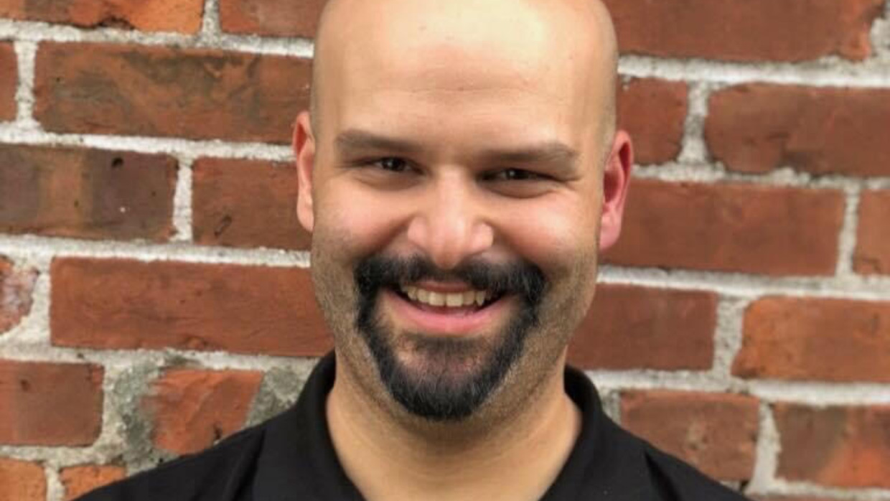

I grew up in New York City, so I thought I had a generally good understanding of what it meant to be Jewish, as far as a Gentile like me could understand. After all, I love Katz’s deli and attended many Passover Seders at my best friend's house.

But teaching biology at Ramaz, an Orthodox Jewish school, this past year showed me how little I knew.

I was bowled over by the students’ collective fearlessness when it came to discussing ideas and debating their points without fear.

I would tell the head of my department whenever there might be a controversial issue that might come up in biology class just to give her a heads up. She would nod her head and say, "Okay, as long as the science is clear to the students." She wasn’t overly concerned with how potentially spirited the debate might get between students.

This is rather different from what I have experienced at other schools where the unspoken rule was to avoid or minimize discussing issues that could be potential hot buttons. Biology is a subject where a lot of landmine issues can be found; issues around gender, race and sexuality can inadvertently turn a lesson into a hotbed of political strife. Even topics as innocuous as natural selection can be a proverbial landmine if a teacher isn’t careful.

Students in the past have confided in me that they are nervous expressing their points of view out of fear that they will be shunned or canceled. I don't know what is in a student’s heart and mind, but at Ramaz not once have I had a student share fears like that with me.

**The Need for Evidence and Logic**

**to Support Your Conclusions**

Jewish culture embraces discussion, argumentation and hearing various points of view and that helps to prevent or at least minimize that kind of idea policing. As part of the culture, students study the Talmud and they learn to read multiple interpretations and commentaries of Torah passages. These students have grown up in a world where it is normal and expected for people to have strong perspectives on important issues, but it’s also expected that your point of view be supported by more than feelings – there needs to be evidence and logic to support your conclusion.

These students have grown into a culture that says, “In order to get closer to the truth, at least as best as humans can approximate it, it’s important to hear multiple perspectives.” This kind of outlook and education is rather different than what many students experience at other educational institutions where they may be less likely to hear or appreciate the idea that respectable people can have differing points of view.

Growing up in a culture that demands logical, refined thinking results in students who may get annoyed at one another for their points of view but don't feel the need to ostracize someone who dissents from the consensus. I have not once seen a student who felt like they couldn't share their opinion on an issue in a class. This kind of fearlessness is refreshing, and all too rare.

**Helping Others**

As important as being able to discuss academic and philosophical issues, the most important thing about education is how it can help challenge a person to go out into the world and make it better because of their engagement. I have seen firsthand the importance Ramaz places on helping students develop this sense of mission and caring about others.

Students talked about their experiences on service trips where they helped renovate houses in New Orleans. On this particular trip students went down to the Lower 9th Ward, an area that still echoes the effects of Hurricane Katrina. They worked all week to renovate homes that were water damaged. Additionally, the students cooked and served over 150 homeless people.

It seems like every week there is a new initiative to help other people. Whether it is toy drives or fundraisers, the spirit of giving permeates this institution and strongly influences students to offer the best of themselves to the world from a young age.

I have taken away a lot of wonderful experiences teaching at Ramaz this year. From learning Hebrew vocabulary from students to learning the basic rules of *Shechita,*ritual slaughter, I have received a taste of a world I only knew at the tiniest level. I am grateful for the opportunity to appreciate a culture that is a beautiful diverse melting pot that has come together in sharing the same values. I'm a better teacher and, hopefully, a bit more of a *mensch* thanks to my time within the Orthodox community.

*Reprinted from the June 18th posting on the aish.com website.*

**The Tragedy of Choosing**

**To be a Grasshopper**

*We were like grasshoppers in our eyes, and so we were in their eyes* (13:33)

The Yalkut Shimoni (quoting Midrash Tanchuma) explains: Hashem said to the spies, “You said, ‘we were like grasshoppers in our eyes.’ For that, I forgive you. But why did you say, ‘and so we were in their eyes’? Who told you that you were not like angels? How do you know what I caused them to think?”

It was this tragic mistake that brought the 40-year punishment. When a person has a distorted and deflated perception of himself, he may totally lose his proper perspective.

While others may view him as an angel, he thinks they see him as a grasshopper. When we see ourselves as insignificant, we have no doubts that others see us the same way, and we are right. People do tend to perceive us as we perceive ourselves. [The Chofetz Chaim] (The Torah Treasury)

*Reprinted from the Parshas Korach 5783 email of The Weekly Vort.*